
Report

Team ID | MCA
Project Name | Smartphone Addiction & Digital Well-Being Insights
Maximum Marks | 5 Marks

A report is a comprehensive document that provides a detailed and structured account of data analysis, findings, and insights. It is typically used for in-depth analysis, documentation, and communication of results. Reports are suitable for a diverse audience, including decision-makers, analysts, and stakeholders who need a comprehensive understanding of the data.
Designing a report in Power BI involves connecting to data sources, creating visualizations like charts and graphs, customizing their appearance and interactivity, organizing them logically on the canvas, formatting elements for consistency and clarity, and optionally creating dashboards for a summarized view. Throughout the process, it's essential to consider the audience's needs and ensure the report effectively communicates insights from the data. Finally, iterate based on feedback to continually improve the report's design and usefulness.

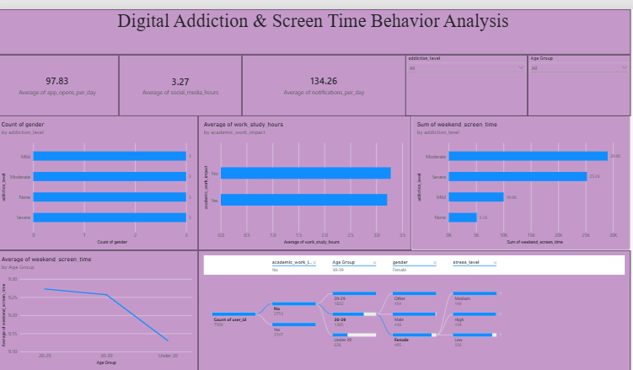
Observations drawn from reports in Power BI can provide valuable insights into business performance and trends.
1. Trends Over Time:
- • Addiction levels skew toward higher severity: Moderate (2.9K) and Severe (2.4K) users far outnumber Mild (1.4K) and None (0.8K), confirming most users fall into the higher-risk addiction bands.
• Weekend screen time rises sharply with addiction severity: Severe (10.4 hrs) and Moderate (10.1 hrs) users show far higher weekend usage than Mild (7.3 hrs) and None (6.2 hrs), a ~4-hour gap between the extremes.
2. Performance Comparisons:
- • Academic/work impact isn’t driven by time spent: Users reporting No impact average 3.3 work/study hours versus 3.2 hours for Yes, an almost negligible difference, suggesting impact stems from usage quality/intensity rather than hours logged.
• High usage is the dominant pattern: 66.8% of users (13M) fall into the High Usage screen-time category versus 33.2% (6M) in Normal Usage, confirming that heavy smartphone engagement is the norm across this population.
3. Customer Segmentation:
- • Weekend usage declines with age: The line chart shows weekend screen time peaking around 9.25 hrs for the 20–29 group and steadily dropping through 30–39 to Under 20, indicating younger adults are the heaviest weekend users.
• Sleep hours decline with age: Average sleep stays around 6.76 hrs for Under 20 and 20–29 users but drops to 6.72 hrs for the 30–39 group, suggesting a mild downward trend in sleep as users get older.
• Stress levels are broadly balanced: High stress (34.13%), Low stress (33.37%), and Medium stress (32.49%) are nearly evenly split, indicating stress is distributed uniformly across the user base rather than concentrated in one group.
4. Goal Achievement:
- • Social media usage rises sharply with addiction severity: Severe (3.8 hrs) and Moderate (3.6 hrs) users spend noticeably more time on social media than Mild (2.3 hrs) and None (2.2 hrs) users, making it a strong marker of addiction level.
• Daily screen time is the single biggest driver of addiction risk: The Key Influencers panel shows a 2.61-hr increase in daily screen time raises Addicted-status likelihood by 25.47x, far outweighing any other factor on this dashboard.
• High engagement baseline overall: Users average 97.83 app opens and 134.26 notifications per day, alongside 3.27 hours of social media use, reflecting a generally high-frequency usage pattern across the population.
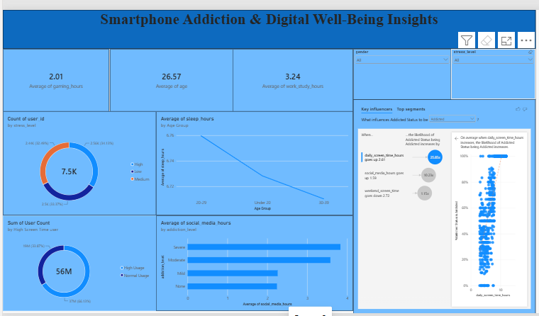
Example:
- Addiction Severity:
- Moderate and Severe users form the largest addiction groups, while weekend screen time is substantially higher among these groups than among Mild and None users.
- Age, Sleep and Weekend Usage:
- Weekend screen time varies by age group, with the 20–29 group around 9.25 hrs and a lower average for older users; average sleep also shows a mild decline with age.
- Engagement and Usage:
- High Usage accounts for 66.8% of users. Average daily app opens are 97.83, notifications are 134.26, and social media use is 3.27 hrs.
- Stress and Academic/Work Impact:
- Stress levels are nearly balanced across High (34.13%), Low (33.37%), and Medium (32.49%). Average work/study hours are 3.3 hrs for users reporting No academic/work impact and 3.2 hrs for Yes.

